Session 4

BTCUSD

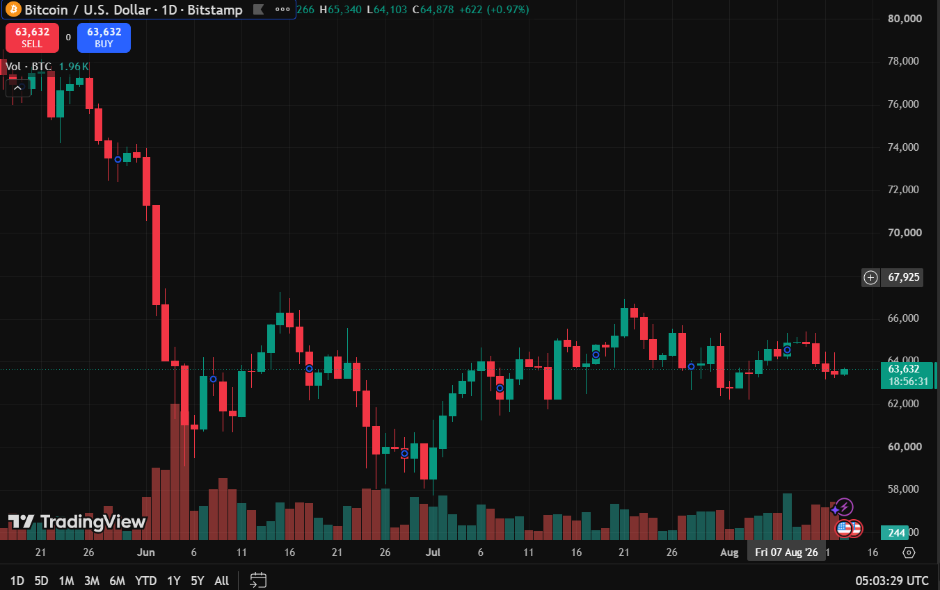

XRP
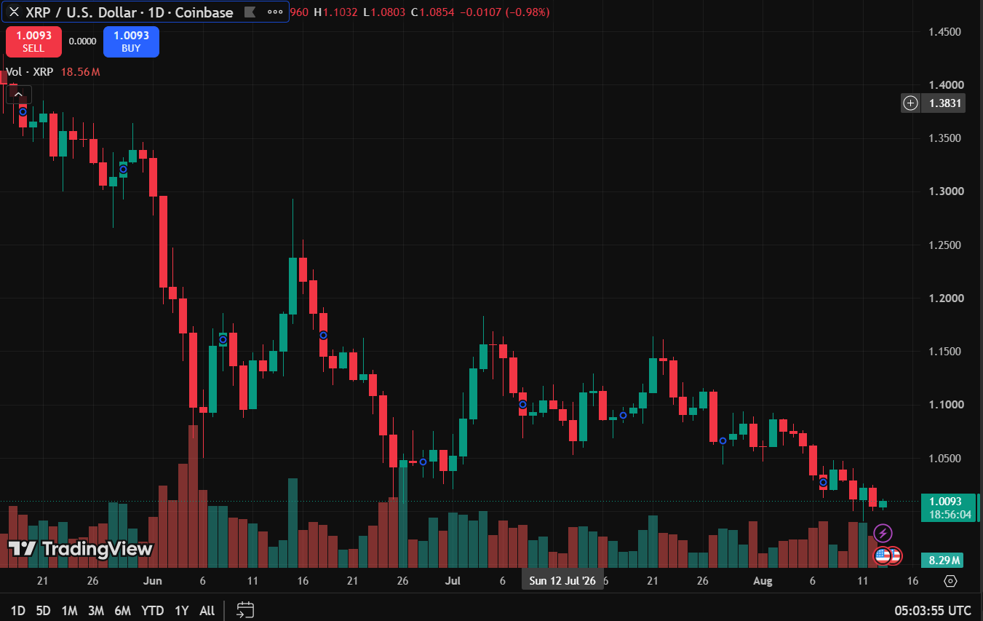

BNBUSDT
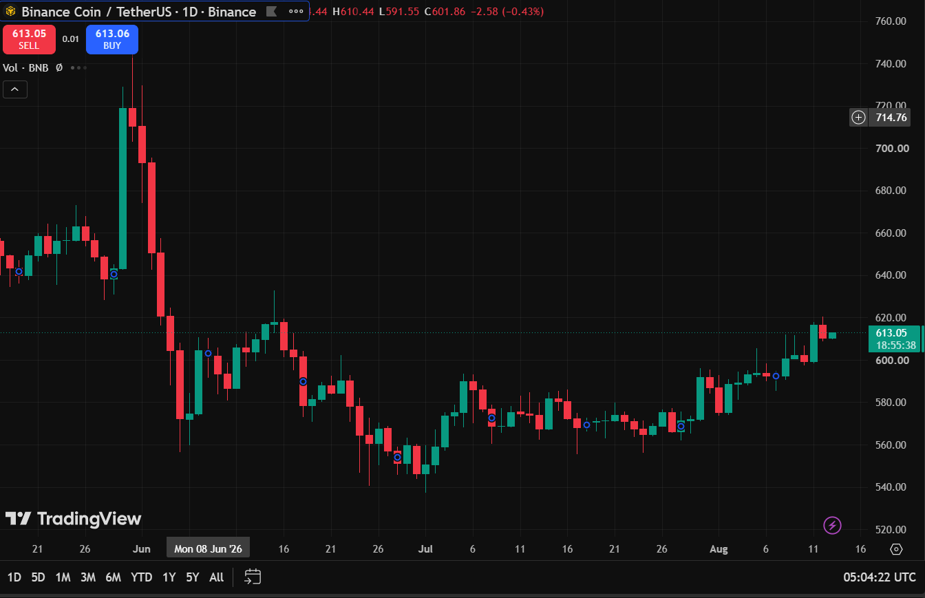

SOLAED

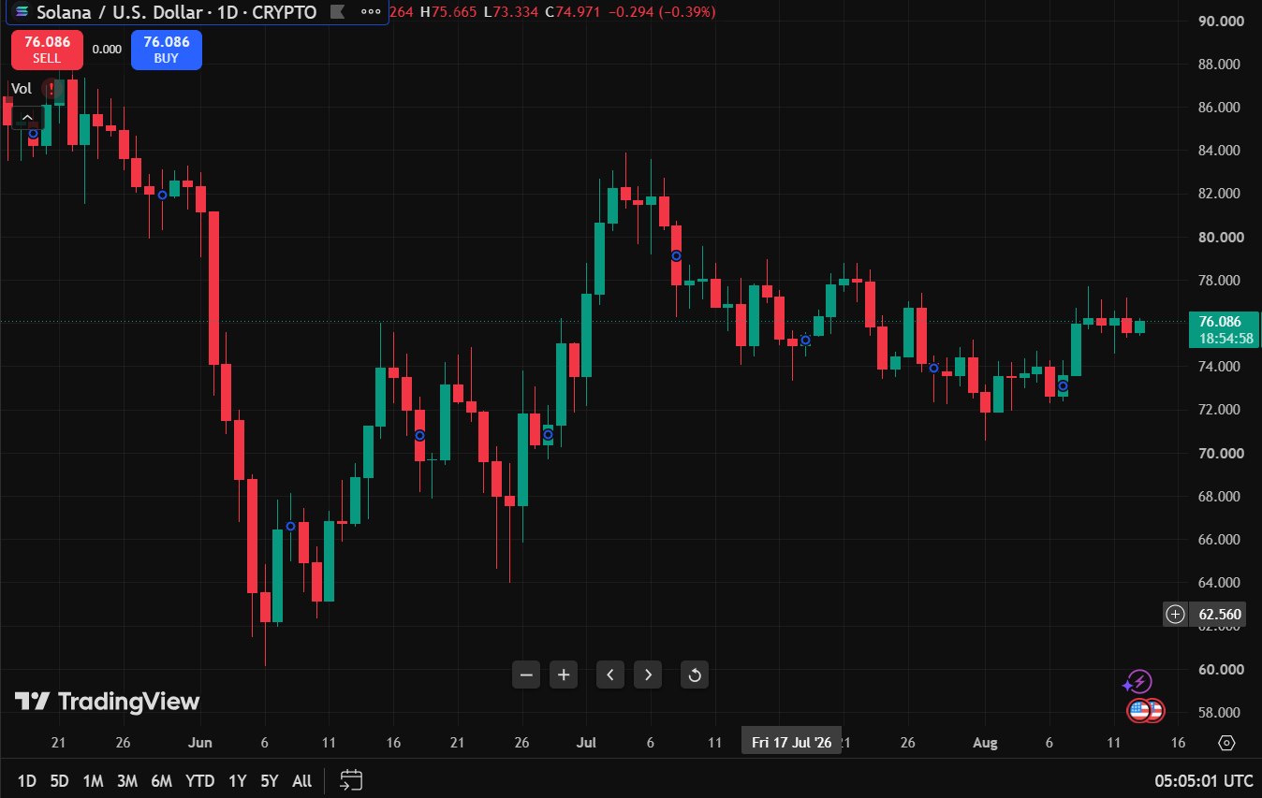

ETHUSD

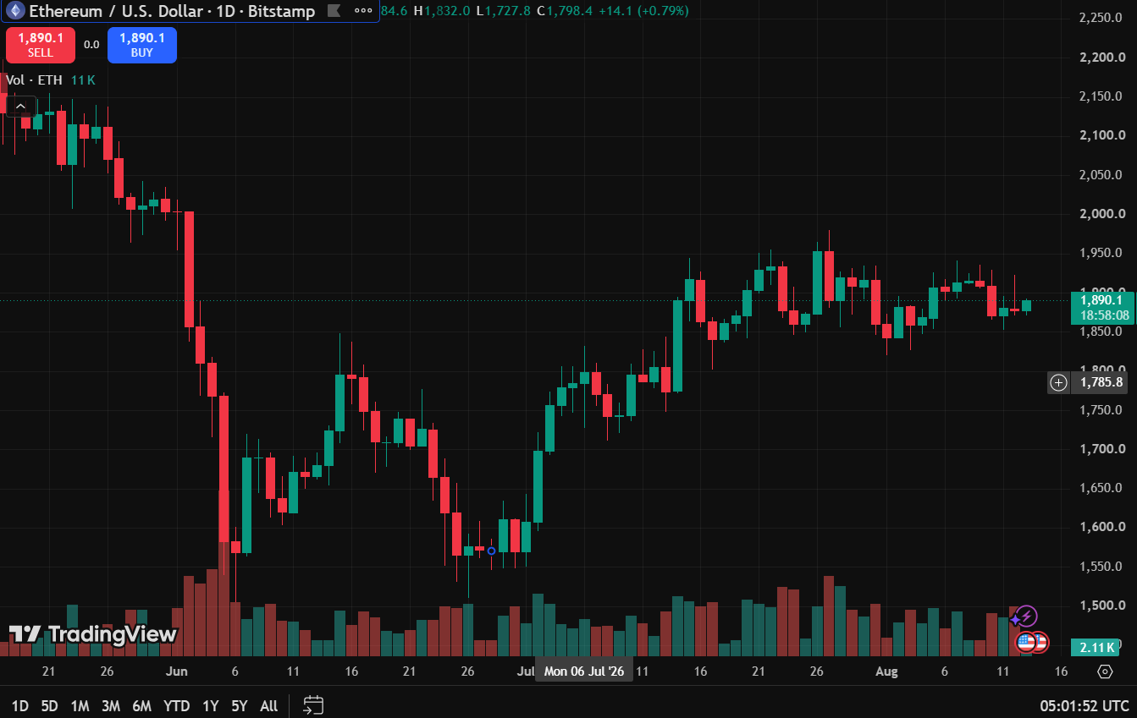

Watch List

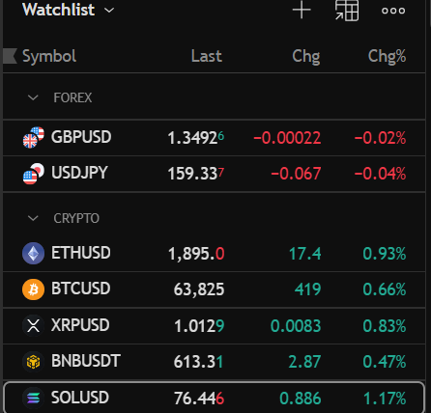

Session 5

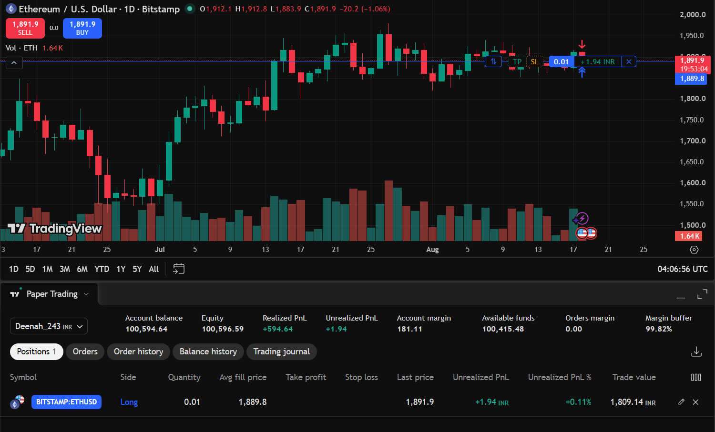

First Trade Record
Trade details

Particular | Details
Asset Name | Ethereum
Symbol | ETHUSD
Trade Type | Buy
Quantity Purchased | 0.01
Average Fill Price | 1,889.8
Trade Value | 1,809.14
Date & Time of Trade | 2026-08-18, 09:33:17

Position Observation
Particular | Value
Last Price | 1,894.6
Trade Value | 1,809.14
Unrealized PnL | +4.58 USD

Session 6

Profit/loss Observation Table

Particulars | Details
Asset Name | Ethereum
Symbol | ETHUSD
Quantity Purchased | 0.01
Purchase Date & Time | 2026-08-18 ( 09:33:17)
Average Fill Price (Purchase Price) | 1,889.8
Exit Date & Time | 2026-08-20 11:50:01
Exit Price (Selling Price) | 2,245.3
Final Profit/Loss (Realized P&L) | +340.11
Trade Outcome (Profit/Loss) | Profit

